University of Baghdad
College of Engineering
Iraqi Journal of Chemical and Petroleum Engineering

Iraqi Journal of Chemical and Petroleum Engineering
Vol.17 No.4 (December 2016) 25- 33
ISSN: 1997-4884

Study of the Performance of Paraffin Wax as a Phase Change Material in Packed Bed Thermal Energy Storage System

Lubna A. Naeem*, Tahseen A. Al-Hattab** and Majid I. Abdulwahab*
*Chemical Engineering Department – College of engineering - University of Baghdad
**Chemical Engineering Department - University of Babylon

Abstract
The present work deals with an experimental investigation of charging and discharging processes in thermal storage system using a phase change material PCM. Paraffin wax was used as the PCM which is formed in spherical capsules and packed in a cylindrical packed column which acted as an energy storage system. Air was used as the heat transfer fluid HTF in thermal storage unit. The effect of flow rate and inlet temperature of HTF on the time of charging and discharging process were studied. The results showed that the faster storage of thermal energy can be made by high flow rate of heat transfer fluid HTF and high inlet temperature of heat transfer fluid. It was found that at 65°C HTF inlet temperature, the melting and solidification processes accelerated by 27.9% and 57.14% respectively, when the flow rate was increased from 9 to 24 L/s. Also, when the HTF inlet temperature changed from 65°C to 80°C, the time needed to complete melting process decreased by 38.8%.

Key words: Phase Change Material PCM, Paraffin wax, Heat transfer fluid HTF, Thermal energy storage TES.

Introduction
In the commercial, industrial, and utility field the energy required vary on daily, weekly, and seasonal bases. These required to energy can be matched with the using of thermal energy storage (TES) systems that operate synergistically. The use of TES for thermal applications such as space and water heating, cooling, air-conditioning, and so on has recently received much attention. TES deals with the storage of energy by cooling, heating, melting, and solidifying material. The thermal energy becomes available when the process is reversed. Storage by causing a material to raise or lower in temperature is called sensible heat storage. Its effectiveness depends on the specific heat of the storage material and, if volume is important, on its density. The rocks or ground used as storage medium in this type. The storage by phase change (with no change in temperature) is type of (TES) known as latent heat storage. Latent heat storage systems store energy in phase change materials (PCMs), with the thermal energy stored when the material changes phase, usually from a solid to a liquid. The specific heat of melting/freezing and the temperature at which the phase change occurs are of design importance. Both sensible and latent TES also may occur in the same storage material [1].
The thermal energy storage in packed bed was used in various applications, such as in retrieving waste heat system and in solar energy storage system that used for air conditioning system with solar energy. The major advantage of these systems is that it provides large surface area to volume ratio, leading to a good heat transfer process. The phase change materials in packed bed have large storage density compared to other storage systems [2, 3].
Paraffin wax was considered as an important material capable of storing energy through phase change. These have the advantage of very high stability over repeated cycles of latent TES operation without degradation. So, paraffin waxes were considered as good PCM candidates [4, 5]. Paraffin wax have desirable properties, it is safe, non-interacting, and congruous with all materials that consist of containers, high latent heat, low or no supper cooling, chemically stable, and different phase change temperature. This leads to make paraffin wax widespread in latent heat thermal energy storage (LHTES) [6, 7 and 8]
Chen and Yue [9] studied experimentally and theoretically the type of water-ice cool storage that packed in capsule, and used for air conditioning. The model used for estimation the thermal properties is one-dimensional porous-medium model. They used water as phase change material PCM that filled capsules of 34mm diameter and packed in cylindrical tube have dimensions 260 mm length, and 100mm diameter, and alcohol used as heat transfer fluid HTF. From their results it was found that there is identification between theoretical and experimental results for different flow rate and inlet coolant temperatures.
Chen et al. [10] examined the thermal behavior of an encapsulated cold TES during charging for varying inlet coolant temperatures and flow rates. An investigation of the thermal characteristics of paraffin wax in a spherical capsule during freezing and melting showed that the average heat transfer coefficient around capsules is affected by the inlet and initial temperature and Reynolds number more during melting than freezing due to the effect of natural convection during melting.
Benmansour et al. [11] provided a two-dimensional transient analysis of a cylindrical storage tank filled with uniformly sized spherical capsules. The paraffin wax in the randomly packed capsules exchanges heat with air, acting as a heat transfer fluid, and the resulting model is found to agree favorably with observations. Cho and Choi [12]; Reddy et al. [13] designed a thermal energy storage system to store large amount of sensible heat and latent heat in a small unit volume with different solar heat sources. The authors used spherical capsules with different size to store PCM in it and packed bed in cylindrical container with capacity 51 liter, 360mm diameter and 504mm height. The storage unit was insulated with 50 mm thickness of glass wool. The experiments were carried out with different materials (paraffin wax and stearic acid) and different diameter of capsules (68, 58, and 38 mm). From the experimental results, the spherical capsules of diameter 38 mm display the better performance in charging and discharging processes. Also, the paraffin wax show little better performance than stearic acid about 5 to 7%, due to the latent heat and thermal conductivity, so it can be considered both paraffin wax and stearic acid good materials for thermal storage unit [13].
Bedecarrrats et al. [14] experimentally studied the thermal performance of water as phase change material PCM encapsulated in spherical capsules which packed in fixed bed during melting and solidification processes. The mono ethylene glycol was used as a heat transfer fluid passes around the spherical capsules to charge and discharge the phase change material. The spherical capsules were used with 77 mm diameter and made from blend of polyolefin, filled the metallic cylinder which represent the thermal storage unit. The experimental data showed that the higher heat transfer rate can be obtained with lower inlet coolant temperature and higher flow rate.
The present work aimed to study the effect of flow rate and inlet temperature of heat transfer fluid (HTF) on the thermal performance of storage system during melting and solidification processes of PCM.

Experimental Investigation
The experimental set up used to study the thermal performance of TES system is shown in Figure 1. It consists of insulated cylindrical thermal energy storage (TES) tank of 25 cm diameter and 50 cm height, filled with spherical capsules that contain PCM. Electrical heater was used to supply heat to the HTF; a rotameter was used to measure the flow rate of HTF; refrigeration device was installed in order to cool the air in order to reduce the time of experiment. The spherical capsules that contain paraffin wax (melting point 58 of ºC) were 4 cm in diameter and they were made from HDPE. PCM capsules were packed as a fixed bed with 4 layers in the cylindrical tank which was insulated with glass wool of thickness 5 cm to prevent heat losing. Four thermocouples are located in the axial direction of the cylindrical tank to record the temperature of PCM and HTF at each layer. Other thermocouples were located at the top and bottom of the storage unit to record the temperature of HTF at inlet and outlet point. A mineral tray was used between each layer of spherical capsules to provide/create uniform void spacing between capsules and layers as well. The thermo physical properties of PCM are given in Table 1.

Table 1: Thermo-physical Properties of PCM
Melting Temperature °C | 56-58
Latent heat kJ/kg | 154.21
Density kg/m³ | 885
Specific heat  kJ/m³K | 2269
Thermal conductivity W/m.°C | Solid at 15 °C | 0.2499
 | Liquid at 60 °C | 0.2397

The volumetric flow rates of HTF used in the experiments are 9, 14, 19, and 24 L/s. The blower was used to circulate the HTF through the storage unit. The inlet temperature of HTF was controlled by using a PID controller. The variables studied during the process include, different air inlet temperatures and air flow rate, while during the discharging process, different air flow rate were used. Initially, the temperature of PCM capsule was maintained at 30-33 °C and as the HTF exchanges energy to PCM, it heated up to its melting temperature. Later, heat is stored as latent heat once the PCM melted and becomes liquid. The energy was then stored as sensible heat in liquid PCM. Temperature of the PCM and HTF are recorded at intervals of 2 minutes.

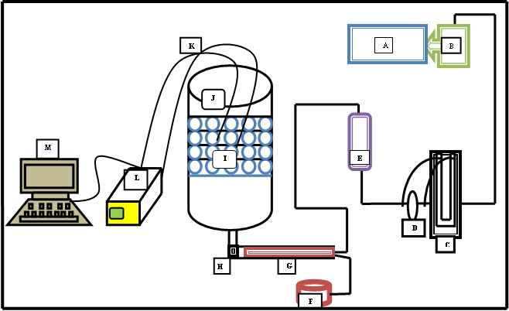
A- Air conditioning device, B- Blower, C- Manometer, D- Orifice meter, E- Rotameter, F- electric heater, G-Rode heater, H-sensor for inlet air, I- TES tank, J- spherical capsules, K- thermocouples sensor, L- data logger, M- PC

Fig. 1: Schematic Diagram of the Experimental Setup

Results and Discussion

- Charging Process
The void fraction of the thermal storage tank (packed bed) packed with 4 cm HDPE spherical capsules was 0.4309. The temperature distribution of PCM and HTF are recorded through the charging process for different flow rate and different inlet temperatures of heat transfer fluid.

  - Temperature Histories of PCM and HTF
The temperature histories of PCM and HTF at four layers (L₁, L₂, L₃ andL₄) of the TES tank are shown in Figures 2 and 3. The PCM temperature distribution during melting process was displayed in Figure 2 for volumetric flow rate of 0.024 m³/sec and porosity of 0.4309. It was observed that the PCM temperature (Tp) increases rapidly at the beginning of the charging period, remains nearly constant around 57 °C during melting process and again increases sharply during heating of liquid PCM. It was found also that the first layer the PCM was completely charged (melted) at nearly 85% of the total charging time due to the high temperature difference between PCM and HTF. The charging process was terminated when the PCM temperature in all the layers reaches 65 °C.

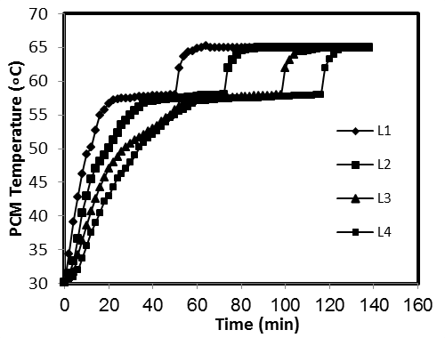
Fig. 2: Temperature History of PCM during Charging Process (Q= 24 L/s; T_{HTF}=65)
Figure 3 displays the thermal performance of the HTF inside the storage tank, for a volumetric flow rate of 24 L/sec and porosity of 0.4309. From Figure 3 it is observed that at all layers, the HTF temperature increases rapidly, this is attributed to the absence of thermal resistance that offered by air to the heat flow and the high driving force (temperature difference) at the first segment. Also, it is noticed that there was higher increase in air temperature than in PCM temperature as more quantity of heat is absorbed by the air than the amount of heat given to the PCM. This is attributed to the higher solid PCM thermal resistance for heat flow [16].

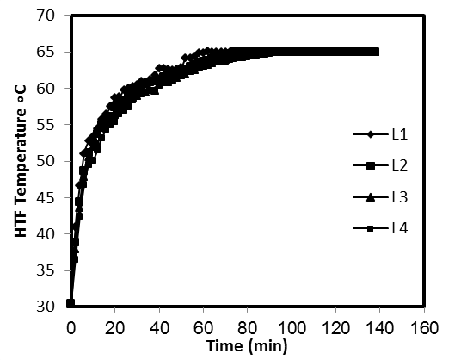
Fig. 3: Temperature History of HTF during Charging Process (Q= 24 L/s; T_{HTF}=65)

  - Effect of HTF Flow Rate
Figure 4 shows the effect of varying the volumetric flow rate of HTF (9, 14, 19 and 24 L/sec) on the charging process of the storage tank. It was found that there was a great influence of increasing volumetric flow rate on the melting process of PCM. The increase of flow rate from 9 to 24 L/sec led to a decrease in the time required for the complete charging process. It was noticed from the figure that the time of charging process is lowered by 9.3%, 16.3% and 27.9% when the flow rate is raised from 9 to 14, 9 to 19 and 9 to 24 L/sec respectively. This is due to that the increase in fluid flow rates causes an increase in surface heat transfer coefficient between the HTF and PCM capsules. Therefore, the time required for charging process was greatly affected by the volumetric flow rate in the storage tank. This is in agreement with Reddy et al. [13] who used paraffin wax with melting point of 61 ºC and stearic acid with melting point 57 ºC as PCMs. And water was being used as HTF.

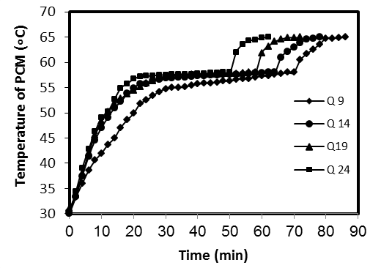
Fig. 4: Effect of HTF flow rate on charging time at L1

  - Effect of HTF Inlet Temperature
Figure 5 shows the relation between the PCM temperature and the charging time. It is observed that the HTF temperature was changing from 65 to 80 ºC to create the comparison with the charging time. The charging time needed to reach 65 ºC is considered and it various with different inlet temperature. It was noted that the increase in HTF temperature causes an increase in the PCM temperature due to the large temperature difference between HTF and PCM and therefore, higher heat transfer rate. A temperature of 65 ºC was reached in 82, 94, 106 and 134 minutes when the inlet temperature was 80, 75, 70 and 65 ºC respectively. It was observed that in 61% time the paraffin wax in layer 4 reached 65 ºC when inlet temperature is 80 ºC, whereas it took 70% and 79% of time when the inlet temperature was 75 ºC and 70 ºC respectively [16]. This is in agreement with Reddigari et al. [17] who used paraffin as PCM with melting point 61 °C and water as HTF in a TES system with different HTF inlet temperatures 66, 68, and 70 °C.

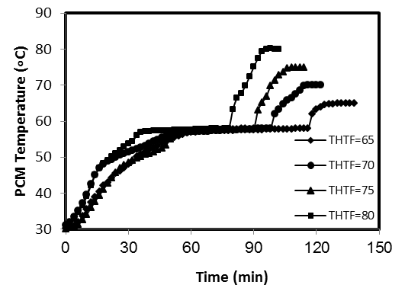
Fig. 5: Effect of Different HTF Temperatures on Charging Time at L4

- Discharging Process
The temperature variation of PCM and HTF was recorded at porosity 0.4309 for different flow rates of HTF ranging from 9 to 24 L/sec through the discharging process.

  - Temperature Histories of PCM and HTF
The discharging process is uniform process at which the PCM start to solidify from the surface toward the center of the capsules. The temperature histories of PCM and HTF at four layers (L₁, L₂, L₃ and L₄) of the TES tank are shown in Figures 6 and 7. Figure 6 shows the temperature distribution of PCM in discharging process with porosity of 0.4309 and for volumetric flow rate of 24 L/sec. From the figure, it is clear that there was three regions; at the first region, the PCM temperature (Tp) decreased gradually at the beginning of the discharging period, at second region Tp remained nearly constant around 57-56 °C, this is the solidification point, and then at the third region, Tp decreased sharply through the cooling of solid PCM to nearly 37 °C.The PCM in the solidification point at L4 is completely discharged at nearly 39.7% of the total discharging time. The discharging process is terminated when the PCM temperature in all the layers reached 35 °C.

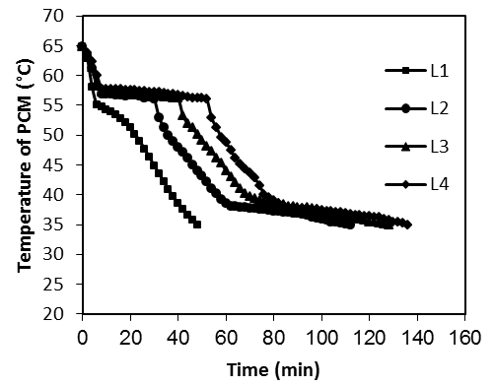
Fig. 6: Temperature History of PCM during Discharging Process (Q= 24 L/s; T_{HTF}=65)

Figure 7 represents the temperature variation of the HTF inside the storage tank for a volume flow rate of 24 L/sec and porosity of 0.4309. It is observed from Figure 7 that the temperature of the HTF at all the layers decreased rapidly, this is due to that there was no resistance offered by the air to heat flow and high driving force (temperature difference) at the beginning of the process. Also, the rate of decrease in temperature is higher in air than in the PCM as a more quantity of heat is absorbed by the air than the amount of heat given to the PCM. This is due to the higher resistance offered by the liquid PCM for heat flow.
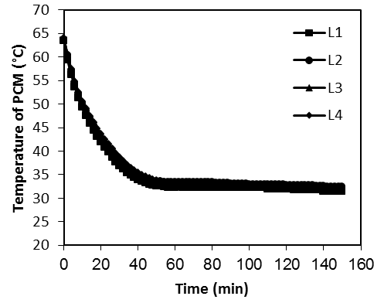
Fig. 7: Temperature History of HTF during Discharging Process (Q= 24 L/s; T_{HTF}=65)

  - Effect of HTF Flow Rate
The discharging process was carried out in different volumetric flow rates (9, 14, 19, and 24 L/sec) to study the effect of changing the volumetric flow rate on the discharging time.
Figure 8 displays the temperature distribution over a period of time. It was observed that the discharging time also decreased to reach 35 °C with the increase in volumetric flow rate of HTF, due to increase heat transfer coefficient that lead to increase heat transfer process. The percent decreased were 28.5%, 53.5%, and 57.14% when the flow rate was increased to 14, 19, and 24 L/sec respectively [16].

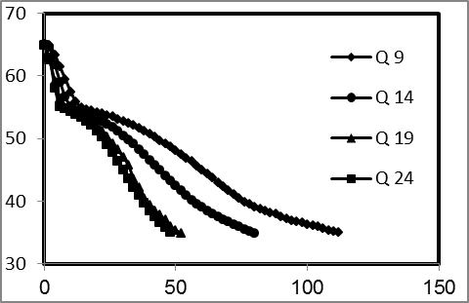
Fig. 8: Effect of HTF Flow Rate on Charging time at L1

Conclusion
Thermal energy storage system was studied with storage sensible and latent heat in PCM with the air used as working fluid. It is concluded that the volumetric flow rate has significant effect on the heat extraction rate from the air and heat recovered to the air which in turn affects the rate of charging and discharging of the TES tank.
Initially, Tp was increased rapidly until reaching the phase change temperature at which it approximately remained constant until the phase change finished and then increased until reaching the inlet HTF temperature.
In discharging, Tp initially decreased rapidly until it reached the phase change region at which Tp remained approximately constant and then it continuously decreased until it reached 35 °C.
Charging and discharging time decreased with increase volumetric flow rate Q from 9 to 24 L/s by 27.9% and 57.14% respectively, and it decreased about 38.8%.with increase of HTF inlet temperature from 65 to 80 °C. Therefore, the high rate of charging and discharging process can achieved with high flow rate and high inlet temperature of HTF.

Nomenclature and Abrevations
TES Thermal Energy Storage
HTF Heat Transfer Fluid
PCM Phase Change Material
Tp Temperature of PCM (°C)
HDPE High Density Poly Ethylene
L1 The PCM in capsule at layer one
L2 The PCM in capsule at layer two
L3 The PCM in capsule at layer three
L4 The PCM in capsule at layer four.
Q Volumetric Flow Rate (Liter/s)
s Second
References
- Dincer I., and M.A. Rosen, 2011, "Thermal Energy Storage: Systems and Applications", 2nd Ed., John Wiley & Sons, Ltd.
- Regin A. F.; S.C.Solanki; and J.S.Saini, 2008, "Heat Transfer Characteristics of Thermal Energy Storage System Using PCM Capsules: A Review', Renewable and Sustainable Energy Reviews, Vol. 12, P. 2438-2458.
- Regin A. F.; S.C. Solanki; and J.S. Saini; 2009, "An Analysis of A Packed Bed Latent Heat Thermal Energy Storage System Using PCM Capsules: Numerical Investigation", Renewable Energy, Vol. 34, P. 1765-1773.
- Roxas-Dimaano M.N., and T.Watanabe, 2002, "The capric and lauric acid mixture with chemical additives as latent heat storage materials for cooling application, Energy Vol.27, P.869–888.
- Zhang Y., G.Zhou, K.Lin, Q.Zhang, and D. Di, 2007, "Application of latent heat thermal energy storage in buildings: state-of-the-art and outlook", Building and Environment Vol.42, P.2197–2209.
- Abhat A., 1983, "Low temperature latent heat thermal energy storage: Heat storage materials", Solar Energy, V.30, No.4, P.313-331.
- Sharma S. D., and K. Sagara, 2004, "Latent heat storage material sand systems: a review", Int. J. Green Energy, Vol.2, P.1-56.
- Himran S., A. Suwono and G. A. Mansoori, 1994, "Characterization of alkanes and paraffin waxes for application as phase change energy storage medium", Energy Source,Vol.16, P.117-28.
- ChenS. L.,and J. S. Yue,1991, "Thermal Performance Of Cool Storage In Packed Capsules For Air Conditioning", Heat Recovery Systems & CHP Vol. 11, No. 6, P. 551-561.
- Chen, S.L., C.L. Chen, C.C.Tin, T.S. Lee, and M.C. Ke, 2000, "An experimental investigation of cold storage in an encapsulated thermal storage tank", Experimental Thermal and Fluid Science 23, P.133–144.
- Benmansour A., M. Hamdan, and A. Bengeuddach, 2006, "Experimental and numerical investigation of solid particles thermal energy storage unit, Applied Thermal Engineering 26, P.513–518.
- Cho K., and S.H. Choi, 2000, "Thermal characteristics of paraffin in a spherical capsule during freezing and melting processes", Int. J. of Heat and Mass Transfer 43, P.3183–3196.
- Reddy R.M., N. Nallusamy, and K. H. Reddy, 2012, "Experimental Studies on Phase Change Material-Based Thermal Energy Storage System for Solar Water Heating Applications", J. of Fundamentals of Renewable Energy and Applications, V.2, 6 Pages.
- Bedecarrats J.P., J. Castaing-Lasvignottes, F. Strub, J.P. Dumas, 2009, " Study of a phase change energy storage using spherical capsules", Part 1: Experimental results, Energy conversion and Management 50, P.2527-2536.
- Mettawee E. B. S., E. I. Eid and Sh .A. M. Amin, 2012, "Experimental Study on Space Cooling with PCM Thermal Storage", J. of App. Sci. Research,V.8 N.7, P.3424-3432.
- Naeem L. A., 2016, "Theoretical and Experimental Study of Thermal Analysis in a Fixed Bed Packed with Nanoparticles Enhanced Phase Change Materials NEPCM", Ph.D. thesis, University of Baghdad.
- Reddigari M. R., N. Nallusamy, A. P. Bappala, And H. R. Konireddy, 2012, "Thermal Energy Storage System Using Phase Change Materials – Constant Heat Source", Thermal Science, Vol. 16, N. 4, P. 1097-1104.

